|  |  |
| --- | --- |
| **LOGIN SCREEN** | |
| Screen Specification | Displays login screen |

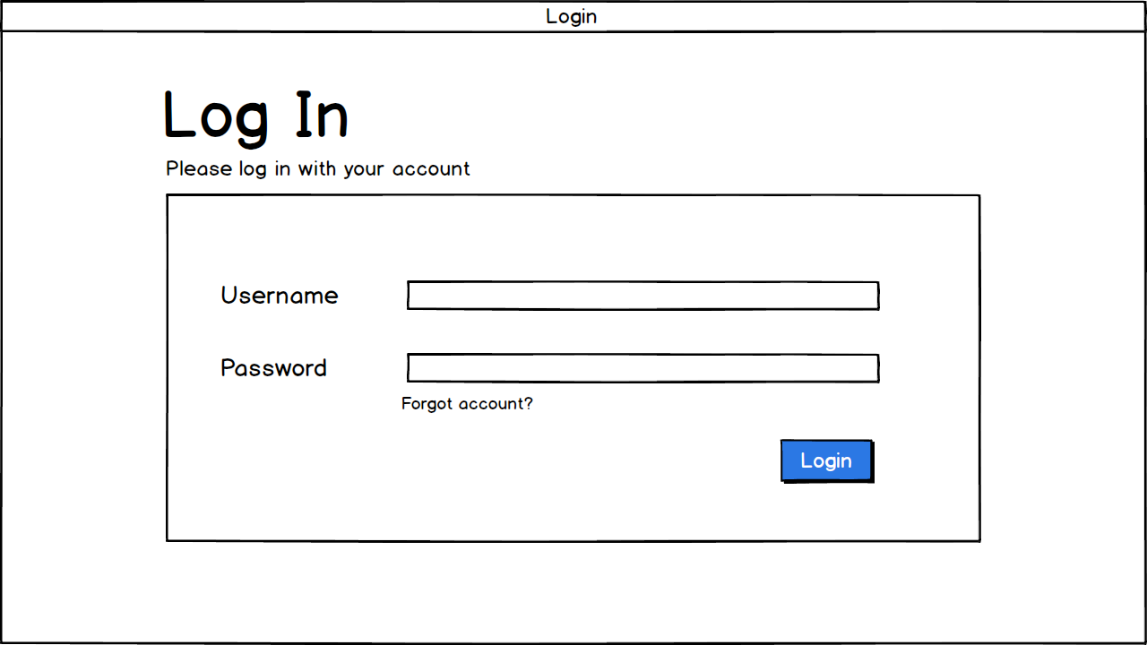

|  |  |  |
| --- | --- | --- |
| Control | Operation | Function |
| Area for displaying login table | Initial | Allows users to login to the site to access all of the features that their account gives them access to |
| Login button | Click | Displays the appropriate account screen |
| Forgot account link | Click | Displays reset password screen |
| Area for input username | Text input | Allows users to enter their username |
| Area for input password | Text input | Allows users to enter their password |

|  |  |
| --- | --- |
| **SALE EMPLOYEE ACCOUNT SCREEN** | |
| Screen Specification | Displays screen of sale employee account |

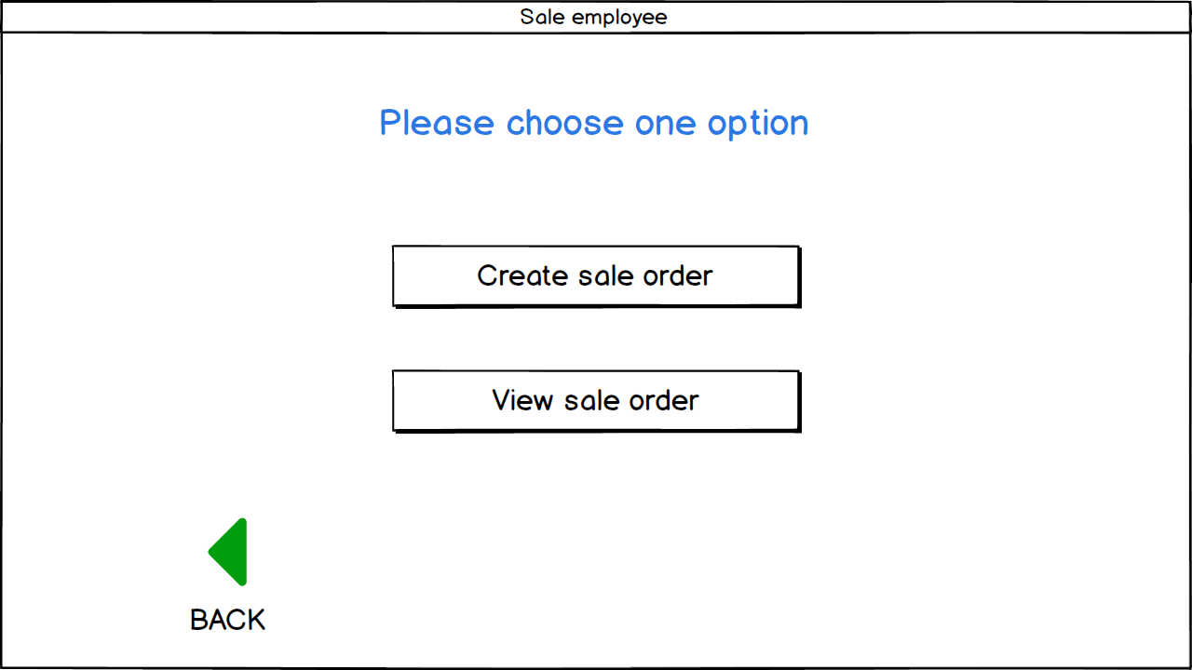

|  |  |  |
| --- | --- | --- |
| Control | Operation | Function |
| Area for displaying option of sale employee account | Initial | Gives some functions for sale employee account |
| Create sale order button | Click | Displays create sale order screen |
| View sale order button | Click | Displays view sale order screen |
| Back button | Click | Displays login screen |

|  |  |
| --- | --- |
| **CREATE SALE ORDER SCREEN** | |
| Screen Specification | Displays screen for creating order |

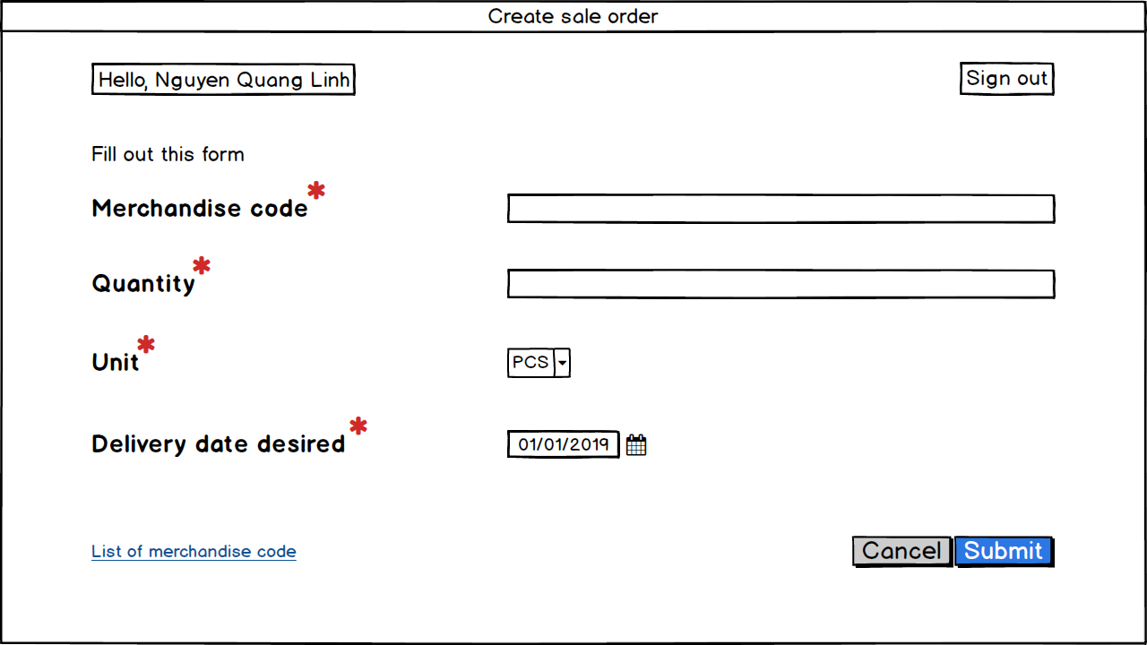

|  |  |  |
| --- | --- | --- |
| Control | Operation | Function |
| Area for create order | Initial | Gives sale employees a place for filling the order |
| Sign out button | Click | Displays login screen |
| Cancel button | Click | Displays sale employee’s options screen |
| Submit button | Click | Displays list of orders screen |
| List of merchandise code link | Click | Displays the list of merchandise codes |

|  |  |
| --- | --- |
| **LIST ORDER SCREEN** | |
| Screen Specification | Displays list of orders screen |

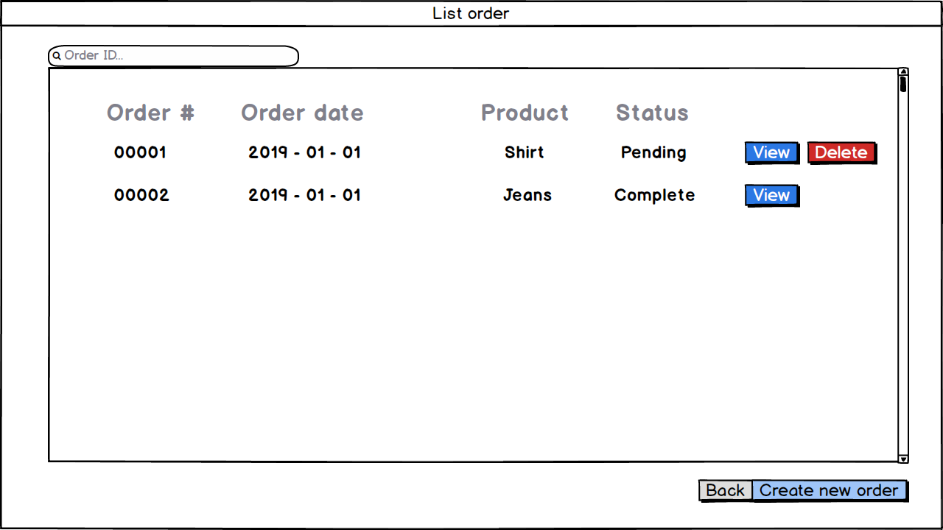

|  |  |  |
| --- | --- | --- |
| Control | Operation | Function |
| Area for list of orders | Initial | Shows all the list of created orders |
| Back button | Click | Displays sale employee’s options screen |
| Create new button | Click | Displays create sale order screen |
| Submit button | Click | Displays list of orders screen |
| View button | Click | Displays the order in detail |
| Delete button | Click | Delete the pending orders |
| Scroll | Scroll | Displays up or down orders |

|  |  |
| --- | --- |
| **DETAILED ORDER SCREEN** | |
| Screen Specification | Displays list of orders screen |

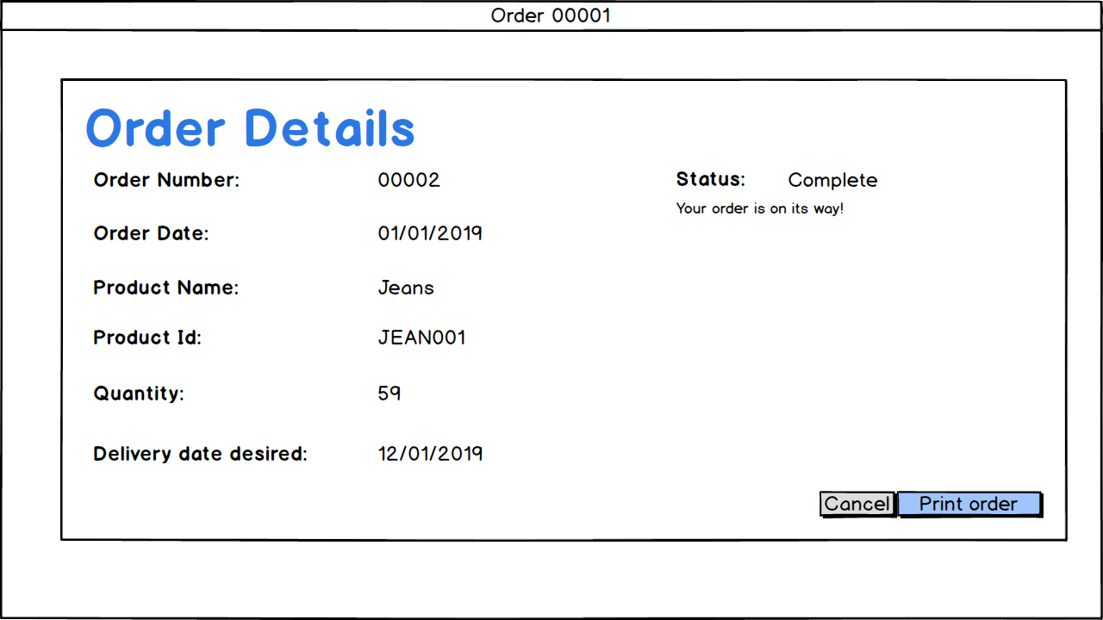

|  |  |  |
| --- | --- | --- |
| Control | Operation | Function |
| Area for detailed order | Initial | Shows detail information of an order |
| Print order button | Click | Prints the order |
| Cancel button | Click | Displays list of orders screen |

|  |  |
| --- | --- |
| **POPUPs** | |
| Screen Specification | Shows popups |

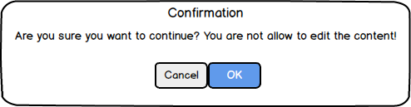

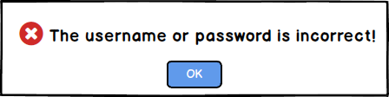

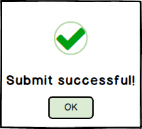

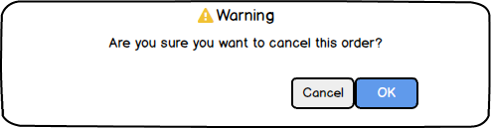

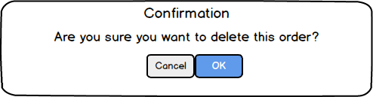

|  |  |  |
| --- | --- | --- |
| Control | Operation | Function |
| OK button | Click | Allows to do the action |
| Cancel button | Click | Not allows to do the action |